Week #4: Physical Wellness

Discussions 3-8 will be covering facets of Digital Wellness as outlined in this Digital Wellness survey from the Digital Wellness Institute. We encourage you to take this survey and then compare your results after a few weeks/months.

NOTE: This survey from the Digital Wellness Institute and all content shared in these study and discussion guides can be shared and used freely for personal and non-commercial use.
We have been deliberate about using materials and images that are either shareable without attribution or within our understanding of fair use guidelines for nonprofits. Please do not use any content for commercial purposes.

https://survey.alchemer.com/s3/5504604/b153c792d361

And please remember that all of these Bringing Digital Wellness Home resources are provided for informational and educational purposes only.

Physical Wellness in a Digital World
This discussion was about how our physical health intersects with our digital life. There are a lot of questions and concrete ideas and we invite you to just set a goal to focus on one thing you could practice this week.

For most of this study and discussion guide, we invite you to look at the slide deck, which can help provide a sort of outline for the information below. There are also images that might help your brain visualize what some of the physical health challenges can look like for you, and possibly make it easier to share the concepts with others. (Attribution-free images can be found at Pexels.com)

Table of Contents

Discussion #4 Slide Deck: 3
Using Your Senses to Ground & Center 3
Physical benefits of reframing stress as a positive/friend/blessing 4
Reviewing the Physical Health questions on the Digital Wellness Assessment/Survey 5
Sleep Hygiene 5
Articles about technology and sleep 6
The Guardian (2017). “Netflix's biggest competitor? Sleep” https://www.theguardian.com/technology/2017/apr/18/netflix-competitor-sleep-uber-facebook 6
More Research on Sleep Hygiene in a Digital Age 6
Overwork vs. Taking Breaks 7
Discussion/Reflection Questions: 7
Exercises to relieve physical strain from digital device use: 7
Some research and information on burnout/stress/overwork 8
Screen-free Eating 9
Discussion/Reflection Questions: 9
Resources and information about mindful eating: 9
Resources and Information about Mindful Driving (a question we would want to add to the self-assessment) 10
Other Physical Health Tips and Tricks 10
Reducing Eye Strain 10
Discussion/Reflection Questions: 10
Some Data about Eyestrain: 10
Infographics for Eye Strain 11
References and Research on Eye Health 12
Email/Screen/Tech Apnea (the tendency to breathe less and/or less deeply while on tech) 14
Discussion slide: 14
More information on breath, meditation, etc. as part of physical health (some different viewpoints exist about how to breathe, so ask an expert for input for your personal situation) 14
Ergonomics 15
Discussion & Reflection slide: 15
Some Resources and Research related to ergonomics 16
Reflection: What are you doing well? What are your weak spots? What do you want to work on this week? 18
Other resources relevant to Physical Wellness (see also resource links in the Productivity document) 18

Discussion #4 Slide Deck:
https://docs.google.com/presentation/d/1zRByL24ziy8E4-ihNXf1YFt0GKR2kZqNJpRMydY2gdI/edit?usp=sharing

Using Your Senses to Ground & Center
This is a topic that we did not cover this time around, but is commonly used to talk about centering and calming.

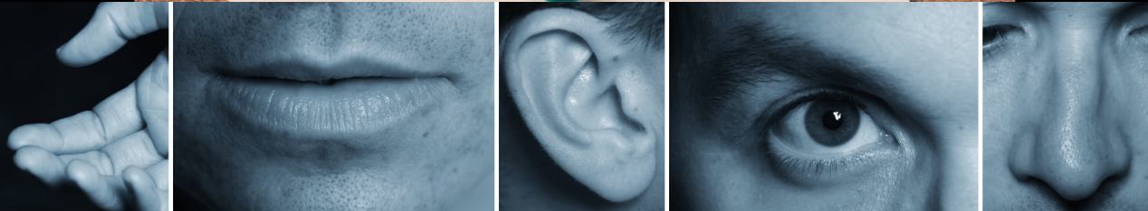

Using your senses to help you ground and center (this is relevant to Mental Wellness and Honoring time as well). There are many resources out there. Here are a few examples:

- Mind-body bridging (See also the book Come to Your Senses by Dr. Stanley Block): https://www.youtube.com/watch?v=tFK9c3N3IVs
- Mind-body-bridging – free three-week series at USU (based on Dr. Block's work) https://chass.usu.edu/social-work/i-system-institute/building-resilience-workshops
- Using the five senses to ground your kids and yourself: https://georgetownpsychology.com/2020/07/using-the-five-senses-to-ground-your-kids-and-yourself/
- https://insighttimer.com/blog/54321-grounding-technique/
- https://ysmtherapyomaha.com/using-your-five-senses-to-ground-your-body-and-mind/
- https://www.urmc.rochester.edu/behavioral-health-partners/bhp-blog/april-2018/5-4-3-2-1-coping-technique-for-anxiety.aspx
- https://www.therapistaid.com/therapy-article/grounding-techniques-article

Physical benefits of reframing stress as a positive/friend/blessing
We discussed research that Kelly McGonigal, Ph.D. spotlights in her TED talk, "How to make stress your friend." She talks about not just the mental health impacts, though, but the physical health impacts of changing how we view and talk about stress. Her book, The Upside of Stress, is one we would recommend.

https://www.ted.com/talks/kelly_mcgonigal_how_to_make_stress_your_friend?language=en&fbclid=IwAR12opz-M6XqS3yBRSpJPkWrYuokNtVOavpawoZck2q59ato5KVhrYK6wI4#t-368757

See also
- https://news.stanford.edu/2015/05/07/stress-embrace-mcgonigal-050715/
- https://cimbaitaly.com/wp-content/uploads/sites/6/2015/12/Als-Book-Club-PDF-December-2015.pdf
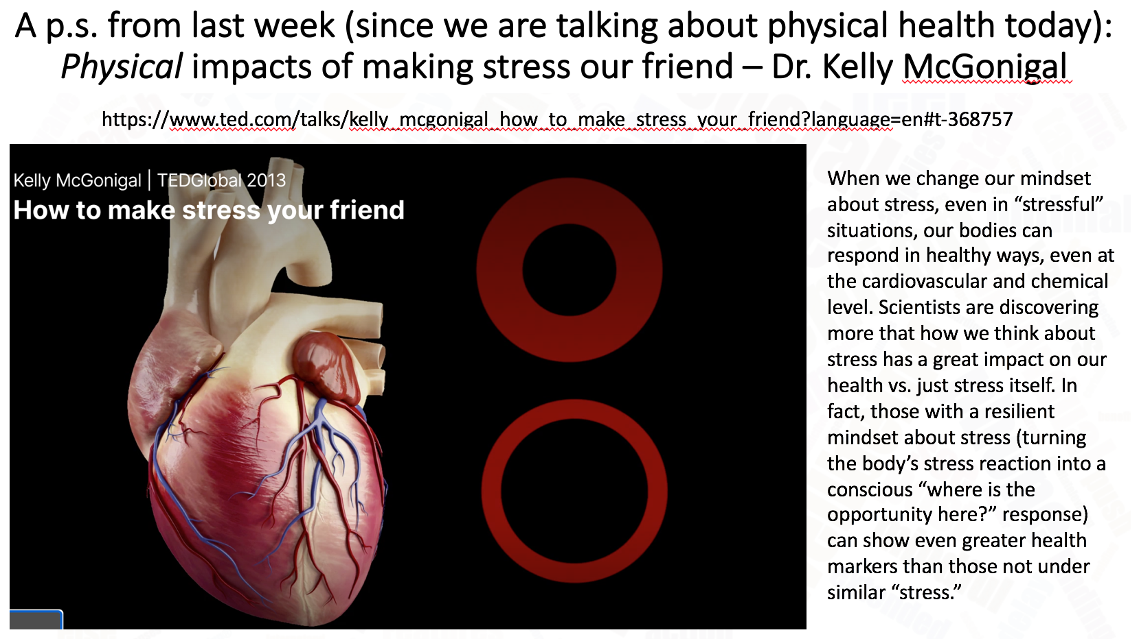

Reviewing the Physical Health questions on the Digital Wellness Assessment/Survey
Survey link here: https://survey.alchemer.com/s3/5504604/b153c792d361

Sleep Hygiene
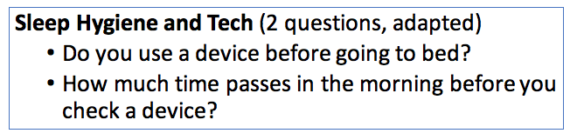
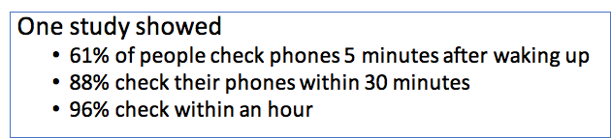
https://www.bgr.in/news/61-people-check-their-phones-within-5-minutes-after-waking-up-deloitte-435501/

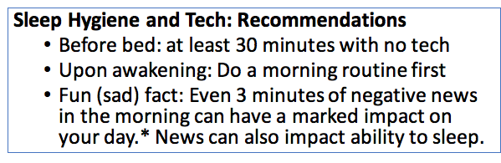
*https://michellegielan.com/project/hbr-consuming-negative-news-can-make-you-less-effective-at-work

Articles about technology and sleep

The Guardian (2017). “Netflix's biggest competitor? Sleep” https://www.theguardian.com/technology/2017/apr/18/netflix-competitor-sleep-uber-facebook
- Huffington Post (2015). A Sad Number Of Americans Sleep With Their Smartphone In Their Hand. https://www.huffingtonpost.ca/entry/smartphone-behavior-2015_n_7690448?ri18n=true

More Research on Sleep Hygiene in a Digital Age
- ASA Authors & Reviewers Sleep Physician at American Sleep Association Reviewers and WritersBoard-certified sleep M.D. physicians, scientists, editors and writers for ASA. (2019, June 1). Sleep Statistics - Data About Sleep and Sleep Disorders. American Sleep Association. https://www.sleepassociation.org/about-sleep/sleep-statistics/
- Erickson, M., Costello, P., Stafford, R., Goldman, B., & Benzkofer, S. (2020, June 3). Setting your biological clock, reducing stress while sheltering in place. Scope. https://scopeblog.stanford.edu/2020/06/03/setting-your-biological-clock-reducing-stress-while-sheltering-in-place/
- Harvard Health Publishing. (2020, July 7). Blue light has a dark side. Harvard Health. https://www.health.harvard.edu/staying-healthy/blue-light-has-a-dark-side
- Klearman, E. (2017, November 1). Optimizing the Sleep-Wake Cycle. Dr. Klearman : A Center for Natural Health. https://drklearman.com/sleep-wake-cycle/
- The science of sleep: http://healthysleep.med.harvard.edu/healthy/science
- Short- and long-term health consequences of sleep disruption. (2017). PubMed Central (PMC). https://www.ncbi.nlm.nih.gov/pmc/articles/PMC5449130/#:%7E:text=have%20been%20reported.-,Short%2Dterm%20consequences%20of%20sleep%20disruption%20include%20increased%20stress%20responsivity,problems%20in%20otherwise%20healthy%20individuals
- Sievers, M. (2020, November 3). 70+ Sleep Statistics and Trends You Shouldn’t Hit Snooze on for 2020. Casper Blog. https://casper.com/blog/sleep-statistics/
- Sleep and impact on depression, a meta-study: https://jamanetwork.com/journals/jamanetworkopen/fullarticle/2777741
- Sleep Wake Cycles. (n.d.). HOPKINS MEDICINE. https://www.hopkinsmedicine.org/health/conditions-and-diseases/sleepwake-cycles
- Vallance, J.K., Buman, M.P. Stevinson, C. & Lynch, B.M. (2015). Associations of Overall Sedentary Time and Screen Time with Sleep Outcomes. American Journal of Health Behavior, 39, 62-67.

Overwork vs. Taking Breaks
(We'll be talking more about productivity and balance next week.)

Discussion/Reflection Questions:

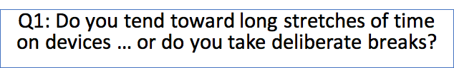

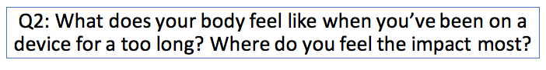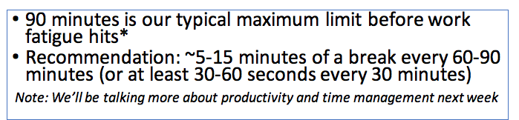

Exercises to relieve physical strain from digital device use:
- Mayo Clinic: Office stretches: https://www.mayoclinic.org/healthy-lifestyle/adult-health/multimedia/stretching/sls-20076525
- Harvard Health hand stretches: https://www.health.harvard.edu/pain/5-exercises-to-improve-hand-mobility
- University of Pittsburgh flexing/stretching exercise compilation: https://www.ehs.pitt.edu/workplace/ergonomics/stretching
- 5 stretches every employee needs: https://alignhq.com/news/2016/4/2/easy-stretching-routines
- 20-minute Tech Tension Meditation https://www.youtube.com/watch?v=olpOsrP_bTI
- Simple exercises to relieve strain and physical pain from digital device use: https://www.painfreeworking.com/exercises/
- "A bizarre reason you should walk" (increasing optic flow = more relaxation in the nervous system): https://drmichaelhunter.medium.com/a-bizarre-reason-you-should-walk-3d79763274bd
- breath and blinks - two ways to tap into autonomic nervous system and to increase optic flow [more in other sections below]

Digital Wellness Institute idea brainstorming around breaks:

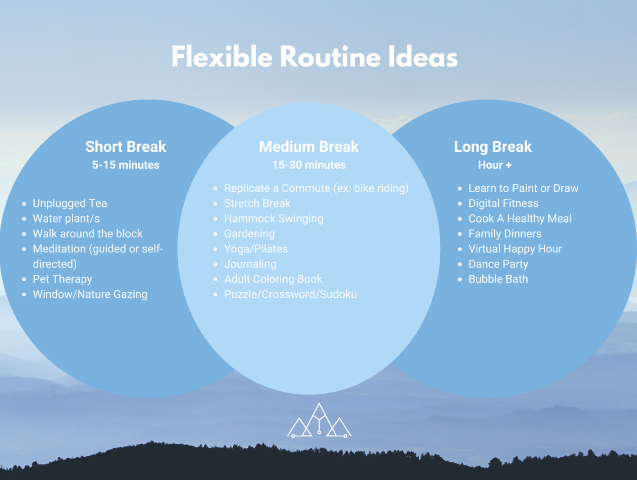

Some research and information on burnout/stress/overwork
- Burn-out an “occupational phenomenon”: International Classification of Diseases. (2019, May 28). WHO. https://www.who.int/news/item/28-05-2019-burn-out-an-occupational-phenomenon-international-classification-of-diseases
- Capritto, A. (2019, May 29). Burnout is now an official medical diagnosis, says the World Health Organization. CNET. https://www.cnet.com/health/burnout-is-now-an-official-medical-diagnosis-says-the-world-health-organization/
- Don’t Leave Your Heart at Work: Profiles of Work–Life Interference and Cardiometabolic Riskhttps://psycnet.apa.org/fulltext/2021-25913-001.html
- Meyer, J. (2020, May 12). Changes in physical activity and sedentary behaviour due to the COVID-19 outbreak and associations with mental health in 3,052 US adults. Cambridge Open Engage.
- Physical activity, mindfulness meditation, or heart rate variability biofeedback for stress reduction: a randomized controlled trial: https://pubmed.ncbi.nlm.nih.gov/26111942/
- Screens and the Stress Response A growing body of evidence links electronic screen media to stress markers. (2012). PYSCHOLOGY TODAY. https://www.psychologytoday.com/ca/blog/mental-wealth/201211/screens-and-the-stress-response

Screen-free Eating

Discussion/Reflection Questions:

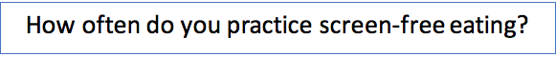
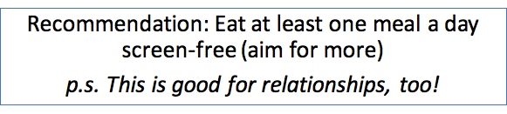

Resources and information about mindful eating:

- Mindful Eating: A Review Of How The Stress-Digestion-Mindfulness Triad May Modulate And Improve Gastrointestinal And Digestive Function: https://pubmed.ncbi.nlm.nih.gov/32549835/
- Mindful Eating: The Art of Presence While You Eat https://pubmed.ncbi.nlm.nih.gov/28848310/
- https://pubmed.ncbi.nlm.nih.gov/19432513/
- https://kripalu.org/resources/seven-tips-mindful-eating-practice

Resources and Information about Mindful Driving (a question we would want to add to the self-assessment)
- Safe driving articles: https://newsroom.aaa.com/2021/10/aaa-finds-better-behavior-behind-the-wheel-but-theres-room-for-improvement/
- https://newsroom.aaa.com/2020/06/bad-behavior-drivers-know-its-wrong-but-many-do-it-anyway/
- Student-led, peer-to-peer youth- initiative called Text Less, Live More:
  - About: "For Merritt" - Merritt Levitan was an accomplished 18-year-old hit by a young, distracted driver who was texting behind the wheel on July 2, 2013. Merritt sustained a traumatic brain injury and died the next day on July 3, 2013. TextLess Live More was founded in the Fall of 2013 by Merritt’s high school friends, led by Emeline Atwood, Abigail Lebowitz, Kaitlin Gately, and Erika Lamere, who were compelled to turn their grief into action to save lives and prevent tragic crashes.
  - https://textlesslivemore.org/
  - https://textlesslivemore.org/resources#facts – stats about texting and driving, and about digital distraction/overuse in general
  - https://textlesslivemore.org/getliving

Other Physical Health Tips and Tricks

Reducing Eye Strain

Discussion/Reflection Questions:
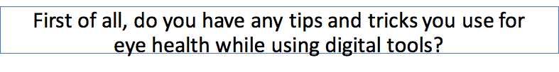
e.g., EPIK's founder, Jan, uses eye drops at the recommendation of her eye doctor to reduce dry eye. Michelle just bought blue light glasses to try...we'll let you know how that goes!

Some Data about Eyestrain:
(see research links for more information)
- Since the iPhone was first introduced in 2007, dry eye has tripled and 80% of people have eye issues related to screen use
- When we are using tech, our blink rate reduces by 65% -- this induces dry eye
- When we blink less, it reduces our oil replenishment, and that can influence our brains ability to maintain attention/concentration/focus

2 or more hours of digital device can lead to the following symptoms:
- sore, tired, burning,
- watering itching
- blurred or double vision
- sensitivity to light
- impacted night vision
- myochemia -- lid muscle spasm or twitch
- headaches
- difficulty concentrating
- etc.

The flip side of this, the good news, is that when we are more aware of our blinking habits while using technology, we can take an active part in our eye health...and our brain health!
Blinks are like a tiny rest period for the brain
https://www.pnas.org/content/110/2/702 or https://www.researchgate.net/publication/233984548_Blink-related_momentary_activation_of_the_default_mode_network_while_viewing_videos]

Basic information about why we blink: https://www.youtube.com/watch?v=MzjOPtInf1c

Infographics for Eye Strain

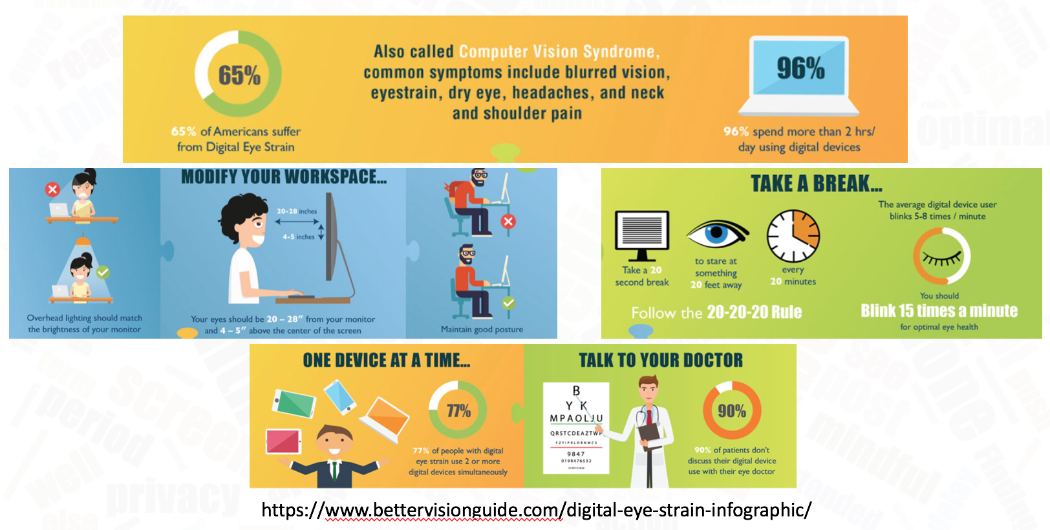

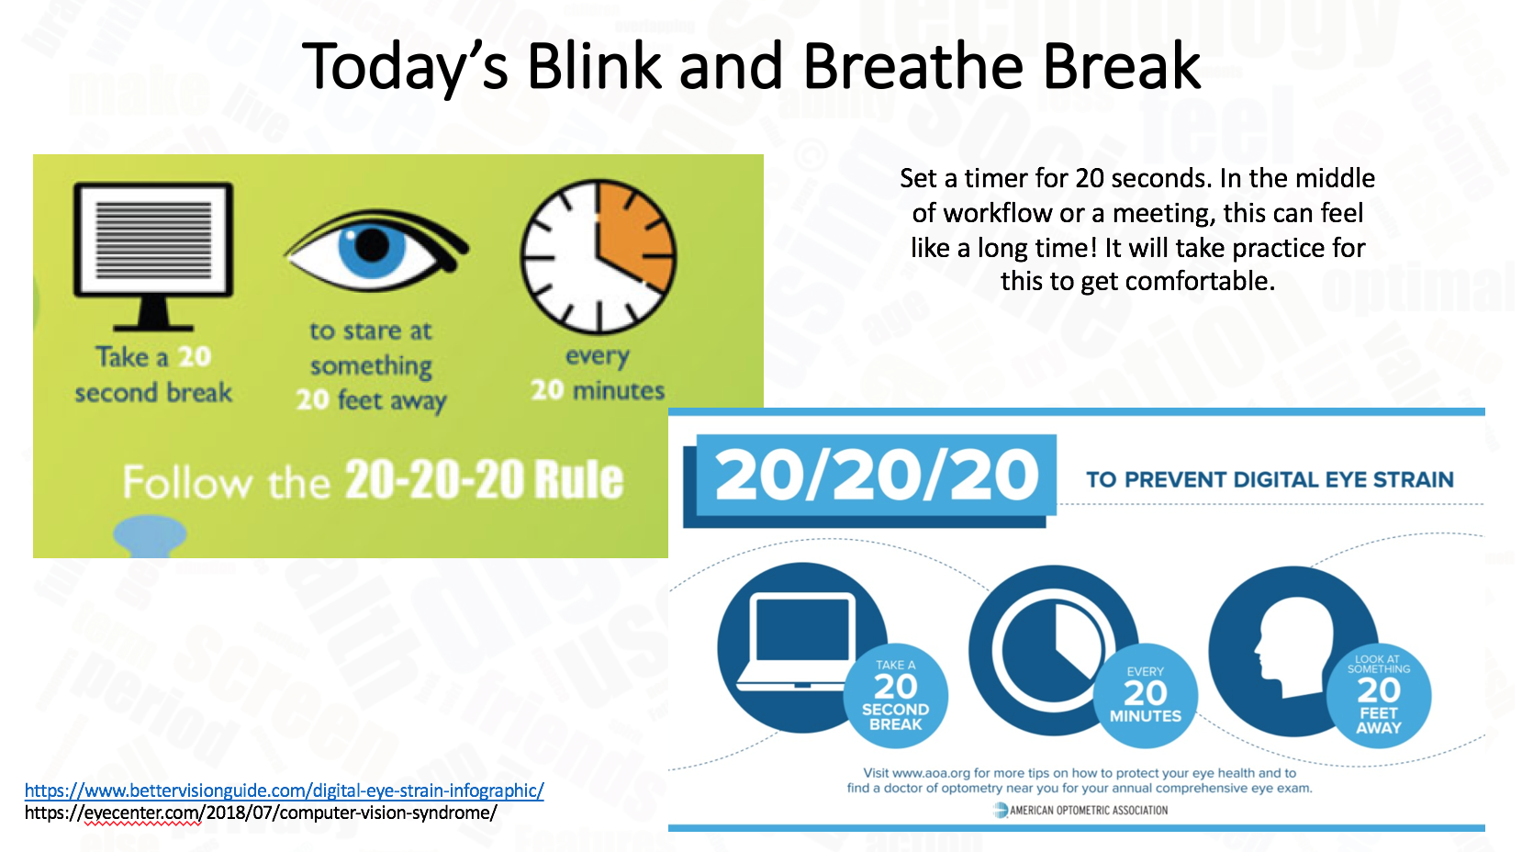

References and Research on Eye Health
- 20-20-20 for kids: https://www.youtube.com/watch?v=b7Jn8-GNB3I
- How blinks can help give the brain moments of rest:
  - https://www.pnas.org/content/110/2/702
  - https://www.researchgate.net/publication/233984548_Blink-related_momentary_activation_of_the_default_mode_network_while_viewing_videos]
- Huberman Lab Podcast: https://hubermanlab.libsyn.com/
- https://www.theeyesight.com/2016/10/24/the-20-20-20-rule-how-to-lessen-the-effects-of-digital-eye-strain/
- Adjusting screen brightness: https://www.pcmag.com/how-to/how-to-adjust-your-pc-monitors-brightness-with-the-right-software
- "A bizarre reason you should walk" (increasing optic flow = more relaxation in the nervous system): https://drmichaelhunter.medium.com/a-bizarre-reason-you-should-walk-3d79763274bd
- Bahkir FA, Grandee SS. Impact of the COVID-19 lockdown on digital device-related ocular health. Indian J Ophthalmol. 2020 Nov;68(11):2378-2383. doi: 10.4103/ijo.IJO_2306_20. PMID: 33120622; PMCID: PMC7774196.
- Are You Blinking Enough? (2016, May 19). VisionSource. https://visionsource.com/blog/are-you-blinking-enough/
- Computer vision syndrome (Digital eye strain). (n.d.-a). AOA. https://www.aoa.org/healthy-eyes/eye-and-vision-conditions/computer-vision-syndrome?sso=y#:%7E:text=Computer%20vision%20syndrome%2C%20also%20referred,digital%20screens%20for%20extended%20periods
- Computer vision syndrome (Digital eye strain). (n.d.-b). AOA. https://www.aoa.org/healthy-eyes/eye-and-vision-conditions/computer-vision-syndrome?sso=y#:%7E:text=Computer%20vision%20syndrome%2C%20also%20referred,digital%20screens%20for%20extended%20periods
- E. (2020a, March 30). COVID-19: Screen Time spikes to over 13 hours per day according to Eyesafe Nielsen estimates. Eyesafe®. https://eyesafe.com/covid-19-screen-time-spike-to-over-13-hours-per-day/
- Estimated Prevalence and Incidence of Dry Eye Disease Based on Coding Analysis of a Large, All-age United States Health Care System. (2019, June 1). ScienceDirect. https://www.sciencedirect.com/science/article/pii/S0002939419300479
- Family Health Team. (2020, September 30). 6 Tips To Help Combat Computer Vision Syndrome. Health Essentials from Cleveland Clinic. https://health.clevelandclinic.org/computers-and-blurry-vision-5-fixes-for-your-tech-induced-eyestrain/
- Harvard Health Publishing. (n.d.). Prevent pain from computer use. Harvard Health. https://www.health.harvard.edu/pain/prevent-pain-from-computer-use
- Impact of digital devices on eyes. (n.d.). Bausch + Lomb UK. https://bausch.co.uk/news/blink-rate#:%7E:text=Their%20concerns%20are%20well%2Dfounded,functional1%2D2%2D3
- Lazarus, R. B. (2021, January 12). Vision and Learning Difficulties. Optometrists.Org. https://www.optometrists.org/vision-therapy/vision-and-learning-difficulties/
- https://www.cambridge.org/engage/coe/article-details/5eb2056d7a31fc00183d05db
- Ramsey, D. (2019a, May 1). Will blue light from electronic devices increase my risk of macular degeneration and blindness? Harvard Health Blog. https://www.health.harvard.edu/blog/will-blue-light-from-electronic-devices-increase-my-risk-of-macular-degeneration-and-blindness-2019040816365
- S. (2020b, May 13). All About Tech Neck | How Smartphones Affect You. Spine INA. https://spineina.com/blog/all-about-tech-neck/
- Steven Sutton. (2015, August 4). Tear break up time. YouTube. https://www.youtube.com/watch?v=qYx1lDUB6YU
- Wapner, J., & Wapner, J. (2020, November 16). Vision and Breathing May Be the Secrets to Surviving 2020. Scientific American. https://www.scientificamerican.com/article/vision-and-breathing-may-be-the-secrets-to-surviving-2020/
- Zalani, R. (2021, January 25). Screen Time Statistics 2021: Your Smartphone Is Hurting You. ECM. https://elitecontentmarketer.com/screen-time-statistics/

Email/Screen/Tech Apnea (the tendency to breathe less and/or less deeply while on tech)

Discussion slide:
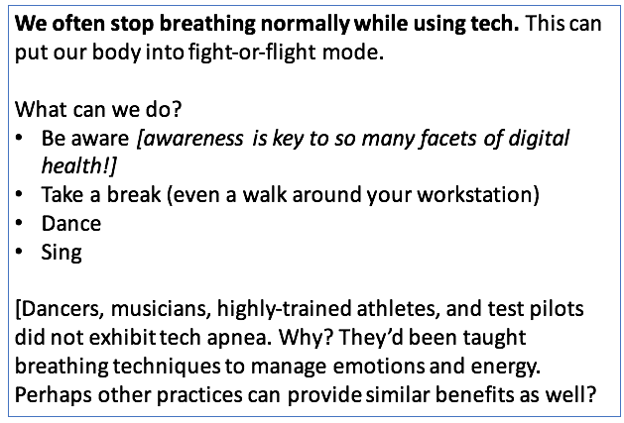
https://lindastone.net/2014/11/24/are-you-breathing-do-you-have-email-apnea/

More information on breath, meditation, etc. as part of physical health (some different viewpoints exist about how to breathe, so ask an expert for input for your personal situation)
- Some of BYU Biofeedback favorite meditations: https://www.youtube.com/playlist?list=PL53WYGVlby86zo0A71SQxH5oo4bJu9uNR
- BYU Biofeedback Relaxation recordings: https://caps.byu.edu/relaxation-recordings
- BYU Biofeedback Paced Breathing recordings: https://caps.byu.edu/paced-breathing
- More about Biofeedback: https://caps.byu.edu/about-biofeedback
- Breath and its impact on Heart Rate Variability: https://www.frontiersin.org/articles/10.3389/fpsyg.2021.624254/
- Guided weekly meditation class via the University of Utah (for pay): https://app.healthcare.utah.edu/peakCourseRegistration/byCourse?primaryId=854
- A video with a physiotherapist about remote work wellness (page also includes some breath and body awareness ideas): https://resiliencei.com/2020/04/remote-work-rhythm/
- How Breath-Control Can Change Your Life: A Systematic Review on Psycho-Physiological Correlates of Slow Breathing https://www.ncbi.nlm.nih.gov/pmc/articles/PMC6137615/
- https://www.scientificamerican.com/article/proper-breathing-brings-better-health/
- Wapner, J., & Wapner, J. (2020, November 16). Vision and Breathing May Be the Secrets to Surviving 2020. Scientific American. https://www.scientificamerican.com/article/vision-and-breathing-may-be-the-secrets-to-surviving-2020/

https://cimbaitaly.com/wp-content/uploads/sites/6/2015/12/Als-Book-Club-PDF-December-2015.pdf

Ergonomics

Discussion & Reflection slide:
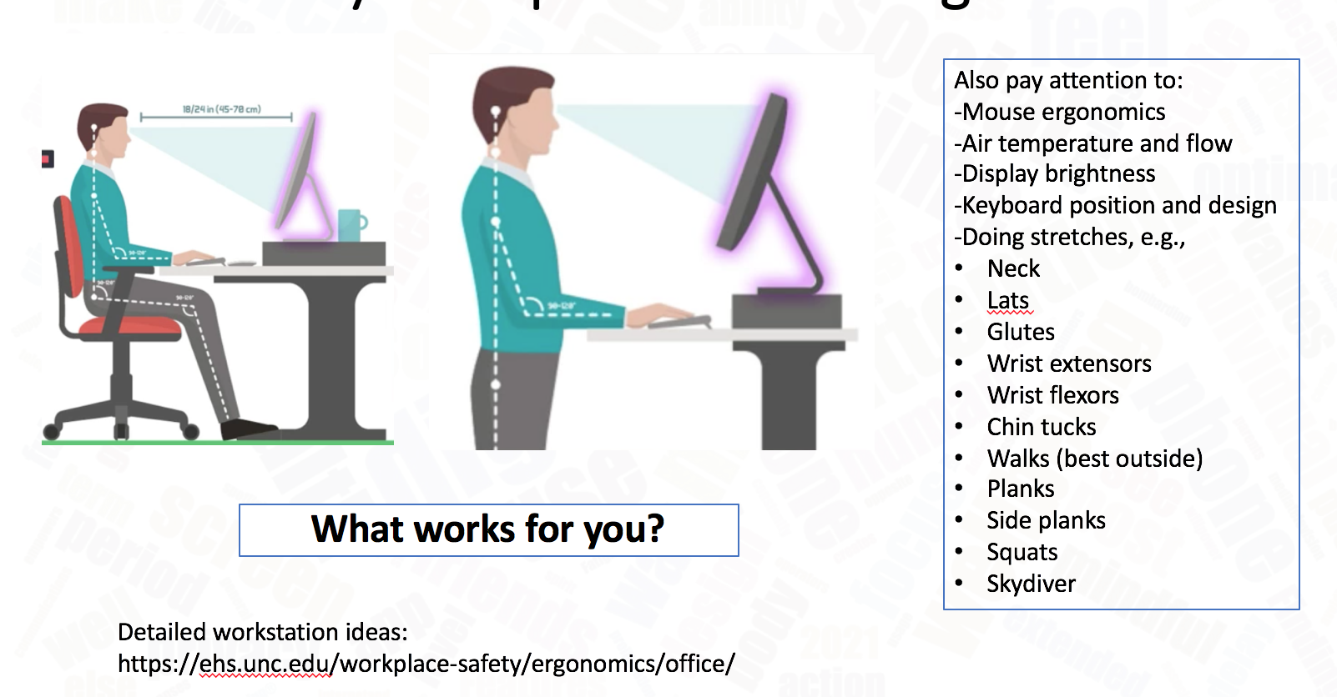

Note: We don't know the source of the above image

Some Resources and Research related to ergonomics
- Quick ergonomics video: https://www.youtube.com/watch?v=F8_ME4VwTiw&feature=youtu.be
- Mayo Clinic: Office stretches: https://www.mayoclinic.org/healthy-lifestyle/adult-health/multimedia/stretching/sls-20076525
- Harvard Health hand stretches: https://www.health.harvard.edu/pain/5-exercises-to-improve-hand-mobility
- University of Pittsburgh flexing/stretching exercise compilation: https://www.ehs.pitt.edu/workplace/ergonomics/stretching
- 5 stretches every employee needs: https://alignhq.com/news/2016/4/2/easy-stretching-routines
- Recommendations for ergonomic workspaces:
  - https://ehs.unc.edu/workplace-safety/ergonomics/office/
  - Bob & Brad (physical therapists): https://www.youtube.com/watch?v=qc2t5Wg_3sk
  - Ergonmic expert tips: https://www.youtube.com/watch?v=F8_ME4VwTiw
- Exercises to address physical strain from digital device use: https://www.painfreeworking.com/exercises/
- Bob & Brad: Joyful Joints videos (neck, back, shoulders, etc.): https://www.youtube.com/playlist?list=PL8l32k1r15l7gUiHux4hDcSTmBs1y6Les and pelvic exercises: https://youtu.be/Yi7sxktkVI0?t=83 (anterior pelvic tilt...arched back that is often tied to sitting a lot)
- S. (2020b, May 13). All About Tech Neck | How Smartphones Affect You. Spine INA. https://spineina.com/blog/all-about-tech-neck/
- Understanding how myofacial pain may be a factor in physical pain from digital and other types of overwork/overuse of parts of the body: https://www.hopkinsmedicine.org/health/wellness-and-prevention/muscle-pain-it-may-actually-be-your-fascia
- Adjusting screen brightness: https://www.pcmag.com/how-to/how-to-adjust-your-pc-monitors-brightness-with-the-right-software
- Tips for ergonomic work: https://www.painfreeworking.com/news/ergonomic-dos-and-donts-when-working-from-home/ or https://ehs.unc.edu/workplace-safety/ergonomics/office/

Research links

Berkeley National Laboratory. (2006, July). Effect of Temperature on Task Performance in Office Environment. Indoor Environment Group. https://indoor.lbl.gov/sites/all/files/lbnl-60946.pdf

Lang, Susan S. (2004, October 19). Study links warm offices to fewer typing errors and higher productivity. Cornell Chronicle. https://news.cornell.edu/stories/2004/10/warm-offices-linked-fewer-typing-errors-higher-productivity

Gordon, Whitson. (2020, July 10). How to Adjust Your PC Monitor’s Brightness With the Right Software. PC Mag. https://www.pcmag.com/how-to/how-to-adjust-your-pc-monitors-brightness-with-the-right-software

Helguera, M., Cannon, K. (2018, April 24). Ergonomics for UX Designers. Heart Internet. https://www.heartinternet.uk/blog/ergonomics-for-ux-designers/

Gavin Morrison, P. (n.d.). Forward Head Posture's Effect on Neck Muscles. Retrieved from https://www.spine-health.com/conditions/neck-pain/forward-head-postures-effect-neck-musclesMahmoud, N. F., Hassan, K. A., Abdelmajeed, S. F., Moustafa, I. M., & Silva, A. G. (2019). The Relationship Between Forward Head Posture and Neck Pain: a Systematic Review and Meta-Analysis. Current reviews in musculoskeletal medicine, 12(4), 562–577. https://doi.org/10.1007/s12178-019-09594-y

Kim, D. H., Kim, C. J., & Son, S. M. (2018). Neck Pain in Adults with Forward Head Posture: Effects of Craniovertebral Angle and Cervical Range of Motion. Osong public health and research perspectives, 9(6), 309–313. https://doi.org/10.24171/j.phrp.2018.9.6.04

Office Ergonomics. (2019, August 11). Retrieved August 17, 2020, from https://ehs.unc.edu/workplace-safety/ergonomics/office/

Page P. (2011). Cervicogenic headaches: an evidence-led approach to clinical management. International journal of sports physical therapy, 6(3), 254–266. https://www.ncbi.nlm.nih.gov/pmc/articles/PMC3201065/

Bontrup, C., Taylor, W. R., Fliesser, M., Visscher, R., Green, T., Wippert, P., & Zemp, R. (2019, July 15). Low back pain and its relationship with sitting behaviour among sedentary office workers. Retrieved from https://www.sciencedirect.com/science/article/pii/S0003687019301279

University of Wisconsin Hospitals and Clinics Authority. (n.d.). Health Information. Retrieved from https://www.uwhealth.org/health/topic/actionset/wrist-care-preventing-carpal-tunnel-syndrome/tn9041.html#:~:text=Arranging your activity and work,a computer keyboard and mouse.

Reflection: What are you doing well? What are your weak spots? What do you want to work on this week?
We'll check in next week and share our personal progress and observations….

Other resources relevant to Physical Wellness (see also resource links in the Productivity document)
- The Body Keeps the Score by Bessel van der Kolk
- When the Body Says No by Gabor Maté
- Come to your Senses - Dr. Stanley Block
- Mind-body bridging: https://www.youtube.com/watch?v=tFK9c3N3IVs
- https://chass.usu.edu/social-work/i-system-institute/building-resilience-workshops
- Mindfulness Utah
- https://www.mindfulnessutah.com/
- Mindfulness exercises: https://healthcare.utah.edu/wellness/resiliency-center/mindfulness.php
- Exercise has long lasting impacts on depression: https://today.duke.edu/2000/09/exercise922.html

