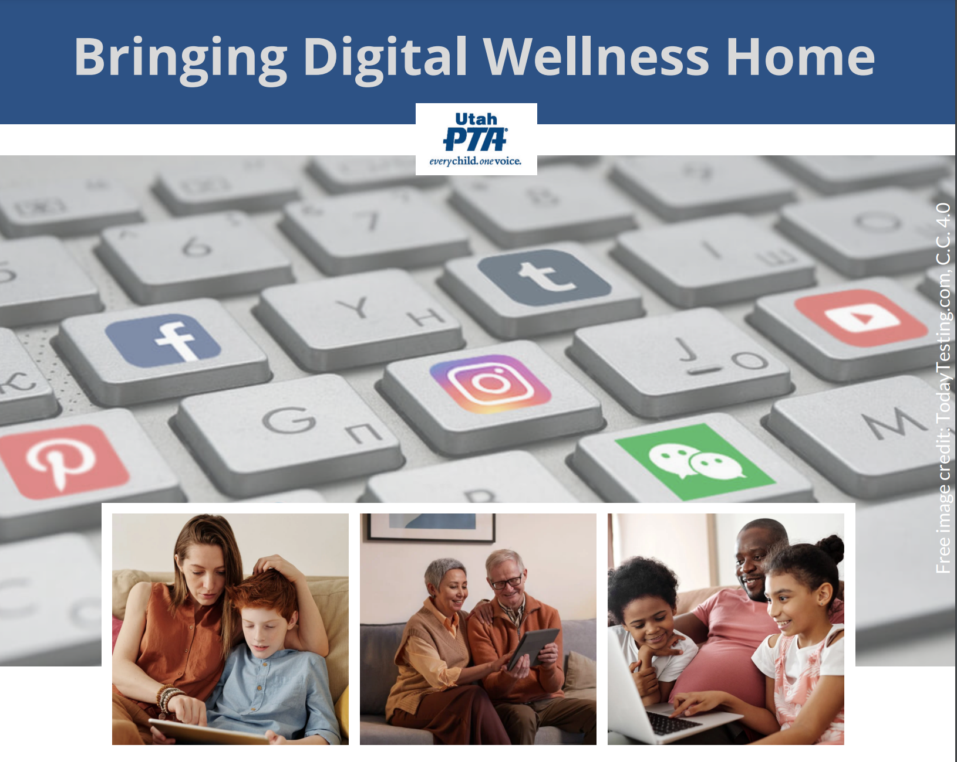

PTA's Bringing Digital Wellness Home Series

Winter 2022

Start with your Center
Family Activity Ideas
These could also be used in a classroom or other setting, including with other adults



There are several family activity ideas that flow out of this week's discussion, in addition to the Values-writing Activity. (Note: If a child is too young to write, you can invite him or her to draw or find pictures in a magazine or help them find other visual ways to represent what is in their young hearts.)

We hope some of the meeting management tools we are using can give you some ideas about how to engage your family members (or students, or others in your sphere of influence) in this discussion. We recommend using the Think, Write, Share approach for at least part of the activity, so that each person has a chance to reflect and write (building instrospection skills), and then share (without fear of interruption).

See also this article at Protect Young Minds: https://www.defendyoungminds.com/post/mentor-digital-kids

Table of Contents

Table of Contents 2
Let's talk about Tech! 3
Find the "Both" 4
What does Digital Wellness mean to you? 6
Values-writing Activity 8
Digital Wellness Journal 8

Let's talk about Tech! (create a culture of conversation)

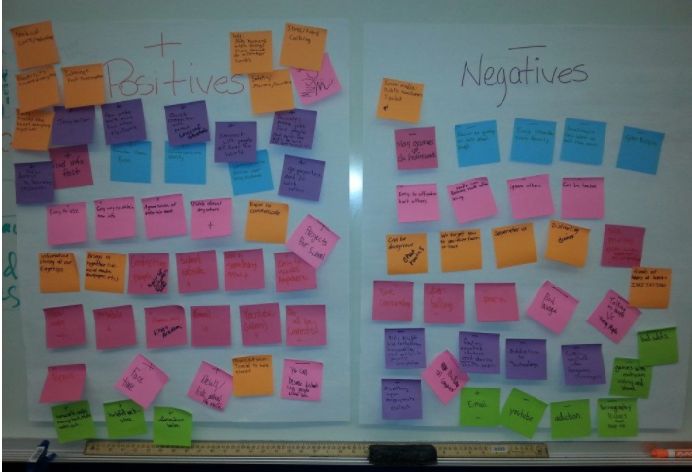
EPIK image from a discussion with youth about the positives and negatives of technology

As we shared in our gathering on January 27 (see also the recording and slide deck), one simple way to start conversations about technology in your home (or classroom or other setting) is to have a discussion about the positives (opportunities, hopes, benefits, etc.) and the negatives (problems, concerns, risks, problems, etc.) about living in the digital age. We shared one free tool you could use if you are having such a discussion online (mentimeter.com), but this activity here is written assuming you might want to do this at home.

When we have engaged youth in this kind of discussion, it has been interesting to observe that they are often more aware of the downsides of technology than we might realize. And we have learned through experience that it's important to give them an opportunity to share some of what it is like to be growing up in this day and age. Talking at them doesn't work. See Devorah Heitner's TED talk on this topic. (Note: We don't advocate smart devices for young children as reflected in this TED talk, but the reality is that even if your children don't have devices, their friends might, and they may be having more exposure to these tools than you might think. And if your children do have limited-access devices, their friends may not. (e.g., My children never had SnapChat in high school, but they knew how it worked.)

One father asked about what he and his wife could do in the face of their boys asking for phones. We pointed him toward this simple idea of building a family culture around more ongoing conversations (vs. one-way parenting), and this is what he wrote. "It just shifted my whole focus to something grander. I believe this can be done without fear as the primary emotion driving it now. I have had several amazingly open [conversations] with my boys. It feels so right [to all of us] to be approaching it this way. I could write so much more, but suffice it to say right now that I feel like I’m ‘reclaiming my role as a father,’ and I don’t know why I’m so surprised that they seem to welcome it. This is a game changer that I’m thrilled about. It’s just so easy to get stuck in thinking you have to fix your [family] system in one big step rather than to engage with your children in a way that builds trust and invites [heart-to-heart connection]."

Find the "Both"



Free image from Pexels.com, a great resource for high-quality images,
–with a caveat/warning that some of the content is not family-friendly

In our group, we had a great mini-discussion about the "both" of Digital Wellness (reducing the negatives and increasing the positives), using Brian Solis' thoughts as a springboard.

There are likely many other quotes out there that you could find about the "both" around technology. But here are Brian's thoughts that I transcribed if you want to use this quote for further personal reflection, or for discussion in your home, classroom, etc.

“[Digital wellness is a] deep self-exploration for understanding where we are in this life and our relationship with technology, or the relationship technology has with us…

"…recognizing that as many things as we juggle at once…as many ways and as many different platforms we [use to] communicate...they all take their toll. Little by little but inevitably...they take their toll. [A]nd that impacts [us] in ways that -- unfortunately when it counts – are going to reveal themselves….

"[S]o this is about going on a journey, not necessarily to take control of technology …[but to] realize that there's…a bigger opportunity for…[how we approach] management of day-to-day life and how [we] use technology in that life…."

“[The goal is to]...get in front of distractions, to get in front of all the potential that we might be missing today.”

-Brian Solis, https://www.youtube.com/watch?v=Kbcilw2WJVw [Note: This is a promotional video for Brian's book. We receive nothing for sharing this. This resource was shared in our DWI course and we found his personal reflections thought-provoking.)

What does Digital Wellness mean to you?

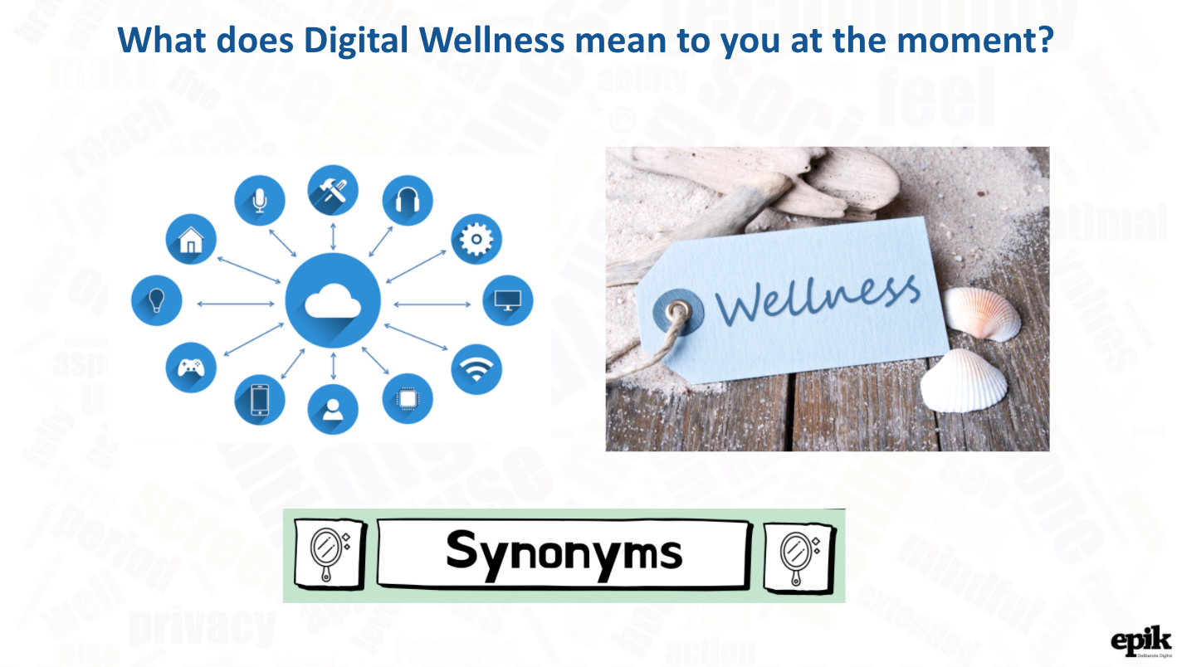
Adaptation of slide 7 from our Week 1 "Start with Your Center" Discussion

This is another example of an (ongoing) conversation you could have with your family.

For time's sake, in our Start with Your Center discussion, we invited you to share simple one-word synonyms for Digital Wellness. You could do something similar (again, using an approach like Think, Write, Share) with single words, i.e.,, you could have each person spend a minute listing synonyms for Digital Wellness and then give each person a minute to share their list, or to talk about one of the words on their list.

You could have some fun and extend the activity to also engage with antonyms (which can also be a great educational opportunity if your children are just learning what a synonym, antonym, homonym, etc. is).

Or you could do a Think, Write, Share where each family member gets to write down different thoughts (not just words, but concepts, phrases, ideas, etc.) and then go around the room to give each person a chance to share. A longer share like this would be best to be timed somewhere between 3-5 minutes (adjust for ages as appropriate, but try to balance the time so everyone feels on equal ground).

We recommend at least one experience going around the room where there is no cross-talk, which means that each person has a chance to share what they have written without comment, feedback, advice, argument, etc. (See the book, You're Not Listening by Kate Murphy.)

The timer helps facilitate this active listening experience and helps create a safe place to share.

Note: When you share in such a roundtable experience, resist the temptation to use your time to comment on others' shares. Or you can use your share time to model what the sharing portion of your conversation looks like. This is another element of a no-cross-talk rule. Commenting on another's share is still cross-talk (even if a comment is positive…because there is the risk of inadvertently reinforcing one person's ideas but not another's). Sometimes it's just good to listen. You can say something like: "Thanks for sharing. You were heard." And then invite the next person to share.

As you engage once in a while as an equal participant vs. putting on the parent hat, it can do wonders for signaling that you are trying to be deliberate in hearing them out and wanting to understand their experiences and perspecitves. Stephen Covey, in his 7 Habits book, calls this "Seek first to understand." We have plenty of ad-hoc moments to do the parent thing. And our children probably know more than we think about all the concerns we have about technology. But do they know we are listening and that we want to understand their world? Do they know we're also trying to be objective about the flip side of the coin? Exercises like Think, Write, Share give our brains opportunities to create space in ways that may not be natural, especially around topics we feel strong emotions around.

Open conversations are great, too, but just be sure that everyone feels heard, seen, and valued.

Values-writing Activity
(& optional craft or shopping trip or other activity that allows each member to make or have a visual reminder of their value)

See https://docs.google.com/document/d/1gR2eK_cHi3e8hczUGQjeW1uFaY5ek7vKBW0m2zZ_KgA/edit?usp=sharing for more details about these activities.

Digital Wellness Journal
You could also consider an activity where each family member can decorate or create some sort of Digital Wellness journal to use for Think, Write, Share activities, personal reflections/instrospection, and personal accountability efforts.



