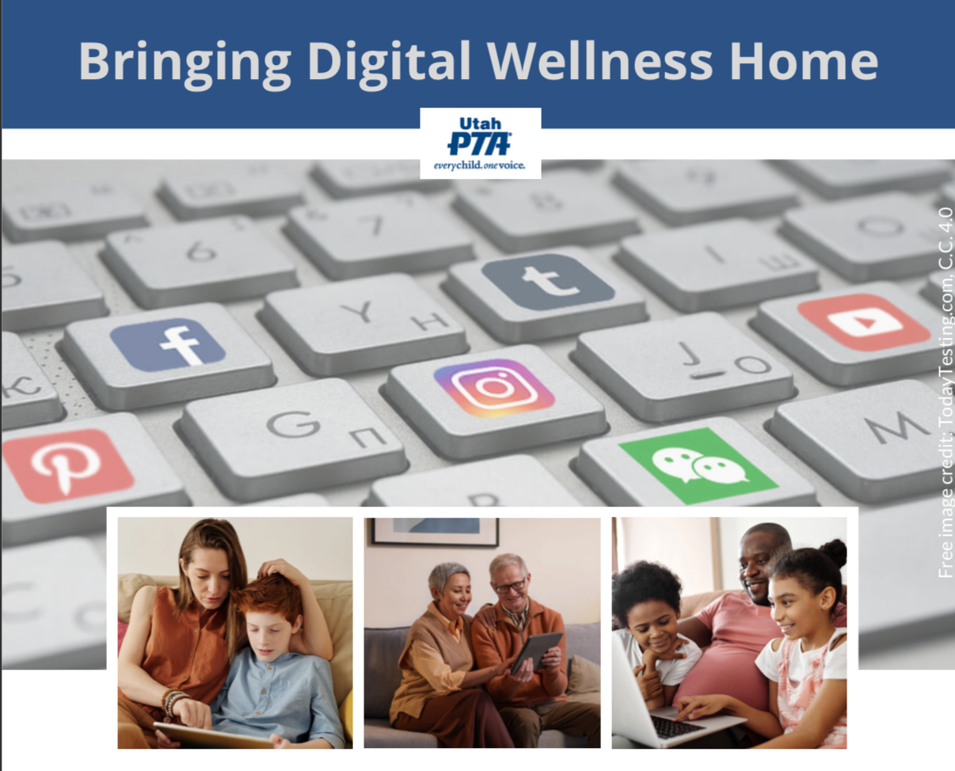

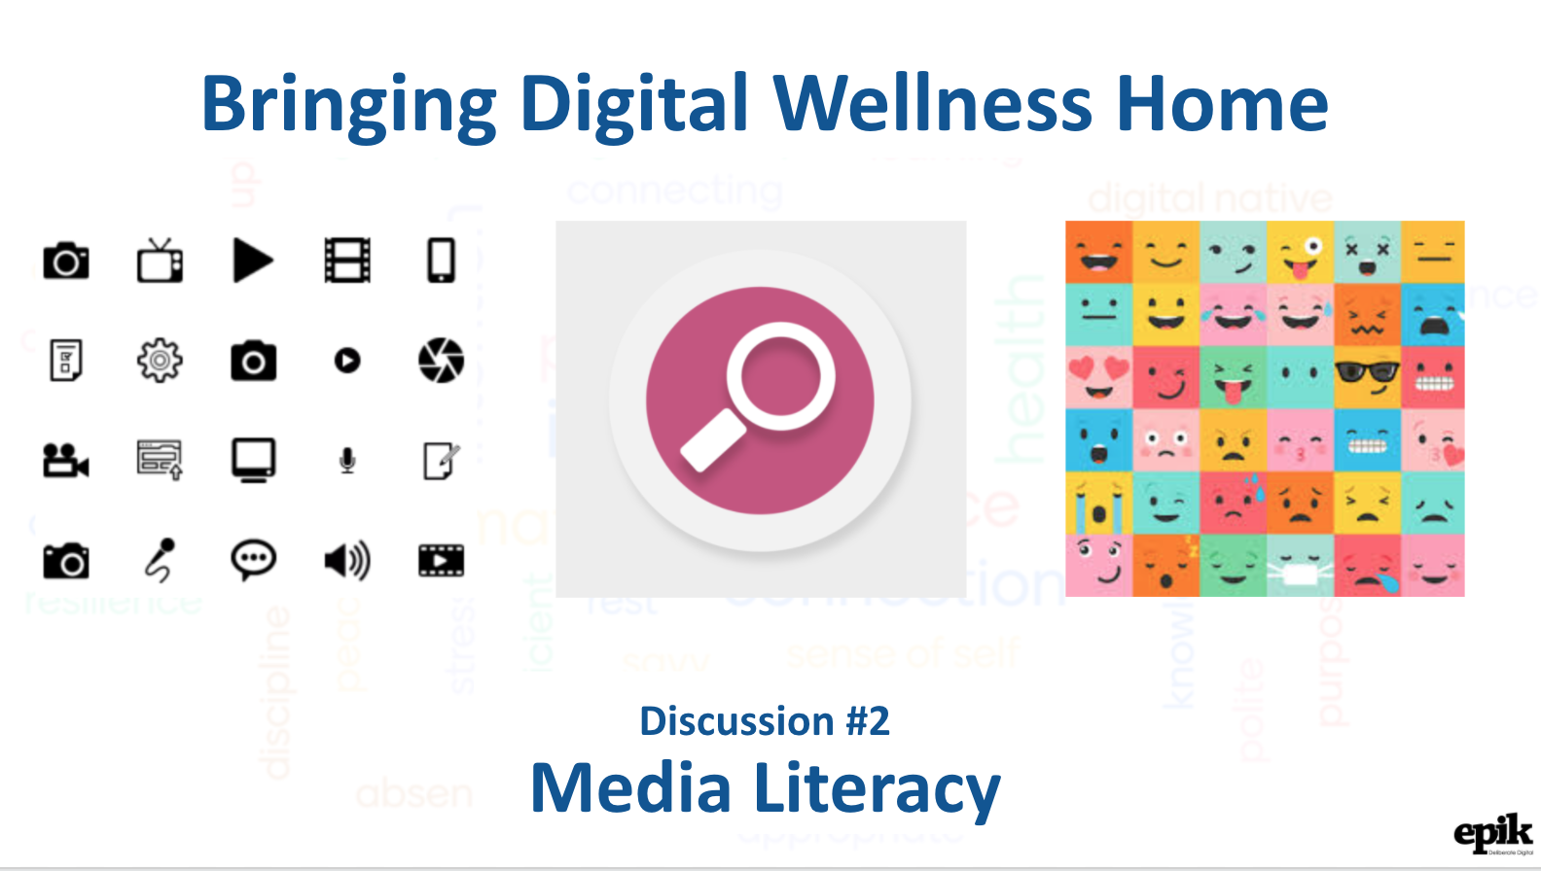

**Additional Media Literacy Activities:**

<https://docs.google.com/presentation/d/14NTP0FluHDh8X-RKb_wXQ7ZockpAQtcO/edit?usp=sharing&ouid=111168784920600095642&rtpof=true&sd=true>

If you prefer a more gamified approach to these kinds of activities, you can find the activities translated into a GooseChase hunt (created by My Discovery Destination when we did a version of this series for their Parent Conversations community). Once you download the app, enter in the code 8XVMZW or try searching on "A Media Literacy Hunt with Wattson."

We will be adding more Media Literacy activities to our slide deck as time goes on, and if you have ideas for other similar activities, let us know!

Discussion with John Linford about core media/touchstones (compass media) – media that help us define, refine, and recenter on our core values:

* On YouTube: <https://youtu.be/aQyWz5A5PN0>
* (on YouTube in smaller bites: https://www.youtube.com/channel/UCm4spkbzbWMzpNSJGrfQQdg/videos)
* Raw video and audio in our "Bringing Digital Wellness Home" unSummit folder: https://drive.google.com/drive/folders/1rmA1in4Kl53vkJJW4s3T3p8pCEKWUmYf?usp=sharing

Teddy's Story Joint (Studio C)

<https://www.youtube.com/watch?v=7uHUb2qXVdw>

P.s. It's been a while since I've seen this. I obviously remembered it as being more about classics, but it's about a whole mix of things that relate back to Media Literacy. Patterns in literature and film can reveal a lot about the human experience (e.g., epic stories about the battles between good and evil) and patterns can also show up in things like political tactics to win favor with the masses. At any rate, it's a fun watch.

Lexie Kite's presentation from recent Davis County Resilience conference

<https://www.youtube.com/watch?v=RQj-nRw4TNQ>

A legal version of the kissing a cheeseburger story from 2013: <https://www.today.com/parents/autistic-girls-broken-cheeseburger-goes-viral-after-kind-waitress-saves-1c9124679>

Small screenshots from the Bonus Material section of the slide deck are below, so you have a visual overview of the many resources that are there, including classical literature lists (by age group), various Media Literacy resources, some data literacy information, and an interesting study about why sometimes people share content that they know is not true, even though they value accuracy. (Sometimes social reasons lead people to share inaccurate content. This can again bring us back to the issue of "How do I want to show up in the world?" It's human to crave attention, but this study supports the idea that if we can value honesty and accuracy, and keep that front-of-mind, it can help reduce spread of mis/disinformation.

