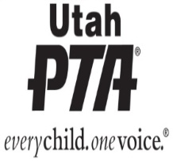
UTAH PTA MILITARY FAMILY MONTH PROCLAMATION
WHEREAS, this year marks Utah PTA’s annual Utah PTA Military Family Month observance ... paying tribute and giving appreciation to military families for their strength, commitment, sacrifices, and unconditional support of our troops; and
WHEREAS, tens of thousands of brave Utahans have demonstrated their courage and commitment to freedom by serving in the military and
WHEREAS, there are over 18,000 children in Utah who have one or more parents, step- parents, siblings, or extended family members on full-time duty status in military service of the United States, including members of the National Guard and Reserves on active duty; and
WHEREAS, the spouses, youth and children of our service members are major contributors to the fabric of strength in their classes and schools every day; and military families continue to make significant contributions to families, schools, communities, our State and the Nation, despite prolonged and repeated absences of one or both parents; and
WHEREAS, these military families are a source of pride and honor to us all, and it is only fitting that we take the time to recognize their contributions, celebrate their spirit, and honor their sacrifices; now
Therefore, I, Corey Fairholm, President of Utah PTA, do hereby proclaim and recognize November 2024 as Utah PTA Military Family Month, and urge my fellow citizens to observe this month by connecting with military children, military families and the communities where we work, live and play to provide support to all our Utah Military Families, and I call this observance to the attention of all our citizens.

____________________________________________
Corey Fairholm, Utah PTA President
__________________________________________________________________________________

