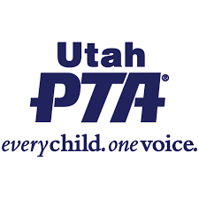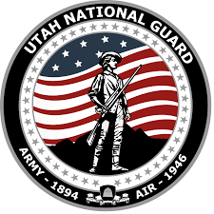

**Utah PTA and the Utah National Guard Invite You to:**

**Utah National Guard Veterans Day Concert**

**TBD**

**To be held in the Tabernacle on Temple Square**

**Utah PTA, in partnership with Utah National Guard, is also holding an essay contest for Military Families! The three winning students from Elementary School, Middle School /Junior High, and High School, from Military Families will be honored at this concert and receive a valuable cash prize!**

**A Military Family is one that has an immediate family member presently serving or who has served in the Active, Reserve or National Guard (Army, Navy, Air Force, Marine Corps, and Coast Guard). If children live with guardians or grandparents who are presently serving or who have served, they are included.**

The theme for the essay contest is “Why I am Proud of my Veteran!” The essays must be no more than 500 words. You can email or send your essays to our Utah PTA Military Family Specialist, Kathy Allred, at the address below. Word format is preferred. The article can be sent any time before the deadline. Please include full name, school grade, school name, mailing address, email address and contact phone number. The articles must be in by Friday, October 18, 2024. If you have any questions or need more information, please contact:

**Jennie Taylor and Kathy Allred,**

**militaryfamilies@utahpta.org**

**Utah PTA Military Family Specialists**

**c/o Utah PTA**

**5192 S. Greenpine Dr., Murray, Utah 84123, 801-261-3100, (Fax) 801-261-3110**