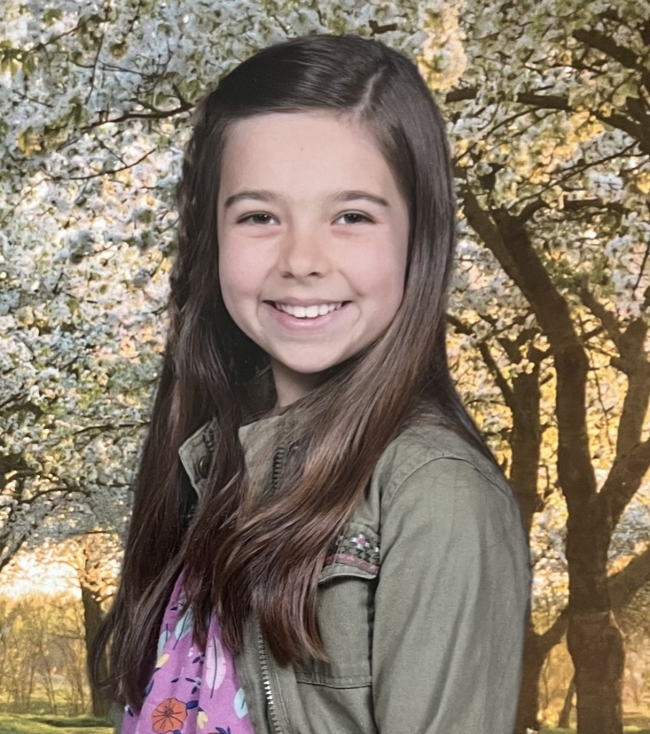
ELEMENTARY SCHOOL WINNER
Alexandra Schumacher Grade 5 Herriman Elementary
Biography
My name is Alexandra Demi Schumacher. I was born on May 25, 2013, in Modesto, California to Marine Corps Major Dmitri Schumacher and his wife Jenna Schumacher.
I am the oldest of three kids Natalia (6) and Dominic (2). I grew up in Los Angeles, Ca until moving to Utah in December 2021.
I am a Girl Scout and member of The Church of Jesus Christ of Latter-Day Saints. I am involved in many activities and am learning Jiu Jitsu, coding, gymnastics, and piano. I am an artist and enjoy creating new things. I enjoy listening to music, dancing, and entertaining my siblings.
I am very proud to win this award. I appreciate this country and all the veterans who serve us, protect us, and make sacrifices for each of us.

Essay
My father is a veteran, United States Marine Corps Officer Major Dmitri Schumacher. He is a fifth generation Marine who recently returned from a deployment in Germany where he helped Ukrainians. This was the second time he had been deployed. The first time he deployed was when my mother had just found out she was going to have me. I am proud of my dad because of the sacrifices he has made by leaving his family to help those you can’t help themselves.
Deploying was hard for my dad because not only did he have to leave his family, but he didn’t know what all he would be doing while deployed. It was hard for him when my siblings and I got hurt, sick, or sad because he wanted to hug and take care of us. He also missed special family events like birthdays, holidays, mission homecomings, and religious ceremonies. Even through all these sacrifices he still worked hard every day even when he missed us.

My dad wasn’t the only one who made sacrifices when he was deployed. It was a big sacrifice for my family too. We had never been away from my dad for that long, so it was hard for him, myself, my siblings, and my mom when he left. As the oldest kid of three I tried to help my mom as much as I could while he was gone.

In conclusion, my father is a great man and I love him so much for what he has done for my family and for his country. I think it takes great bravery, loyalty, and generosity to do what the men and women of our armed forces do every day. I am proud to be Dmitri’s daughter, I am proud that I come from a long line of military, and I am proud to be a citizen of the United States. Semper Fidelis.

